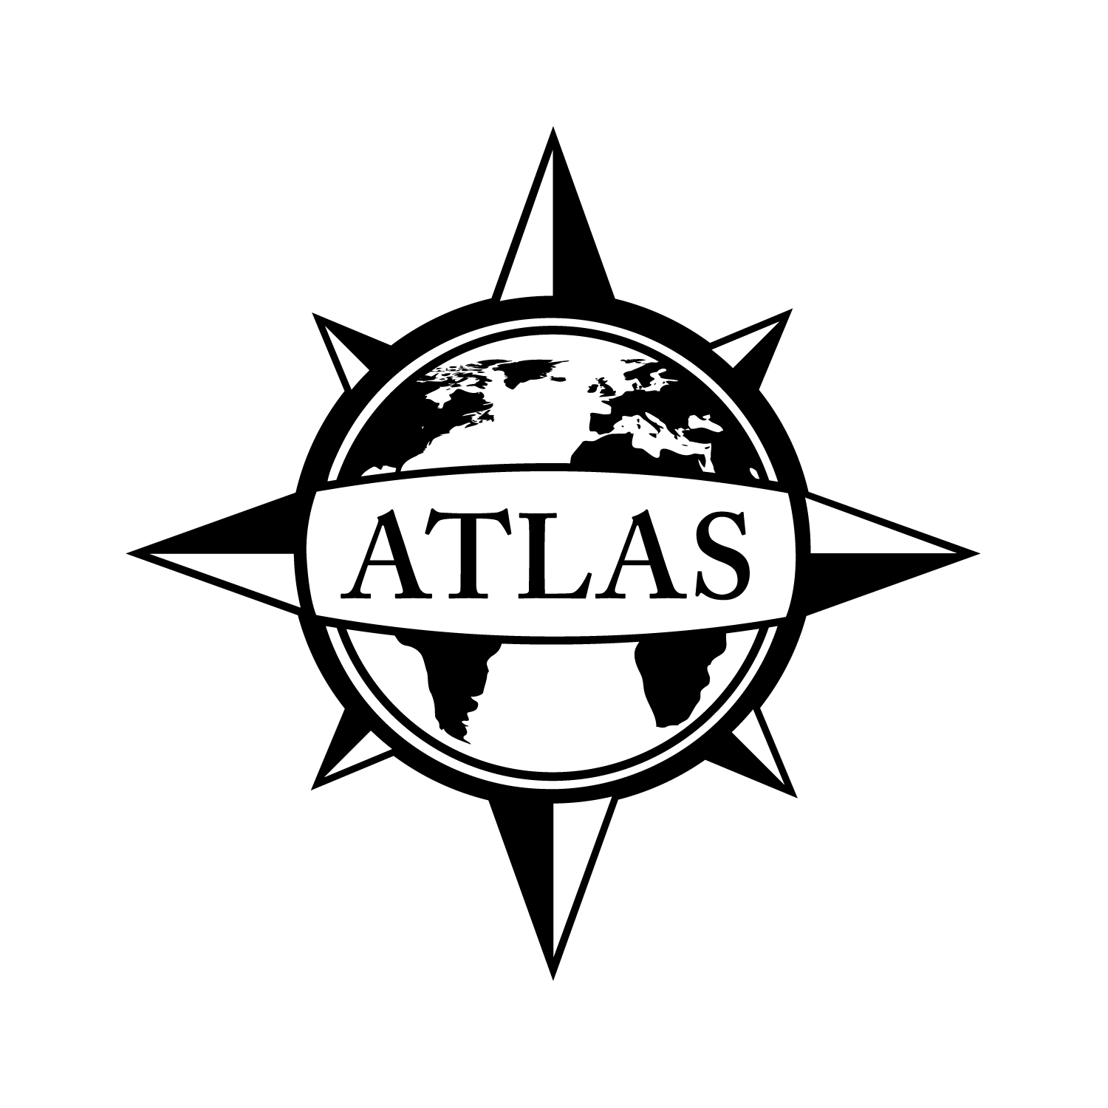2014-2015 Minor in Human Development
College of Liberal Arts
CSULB
23 - 24 Units
This checklist is not intended to replace advising from the department. Consult with the department advisor for appropriate course sequencing. Use this checklist in combination with the Academic Requirements Report, which is the official graduation verification.

 |  |  | Prerequisites
Complete ONE of the following courses (3 units total):
 | ANTH 120: Introduction to Cultural Anthropology (3)  GE: Global Issues; Social Sciences and Citizenship (D2) |  | Corequisite: One GE Foundation
 | HDEV 180: Lifespan Human Development (3)  GE: Social Sciences (D2) or (E) |  | Corequisite: GE Composition
 | PSY 100: General Psychology (3)  GE: Social Sciences and Citizenships (D2) |  | Corequisite: GE Composition
 | SOC 100: Principles of Sociology (3)  GE: Social Sciences and Citizenships (D2) |  | Corequisite: One GE Foundation

Complete ALL of the following courses (17 units total):
 | HDEV/ C/LA 250/PSY 210/SOC 250/BIOL 260: Elementary Statistics in Social and Behavioral Sciences (4) | Eligible for GE Math
 | HDEV 307: Approaches to Childhood Through Adolescence (3)  GE: Capstone (F) or (D2) or (E) | Upper Division Standing; ANTH 120 or HDEV 180 or PSY 100 or SOC 100
 | HDEV 320: Research Methods in Human Development (4) | ANTH 120 or HDEV 180 or PSY 100 or SOC 100 and HDEV 250 or Equivalent
 | HDEV 357: Approaches to Adulthood Through Aging (3)  GE: Human Diversity; Capstone (F) or (D2) or (E) | Upper Division Standing; ANTH 120 or HDEV 180 or PSY 100 or SOC 100
 | HDEV 360: Cultural Foundations for Human Development (3) | HDEV 307 and 357
Complete ONE of the following courses (3 units total):
 | HDEV 300: Death and Dying (3)  GE: Capstone (F) or (D2) or (E) | Upper Division Standing; ANTH 120 or HDEV 180 or PSY 100 or SOC 100
 | HDEV 340: Families and Work: Life Course Processes (3) | ANTH 120 or HDEV 180 or PSY 100 or SOC 100
 | HDEV 402: Development of Thought: Structure, Process and Cultural Influences Across the Life Span (3) | HDEV 320 and 360 or Consent of Instructor
 | HDEV 403: The Acquisition of Culture: Socialization in Cross-cultural Perspective (3) | Majors: HDEV 320, HDEV 360; Non-Majors: Upper Level Cultural Anthropology Equivalent and Consent
 | HDEV 470: Seminar/Practicum (4) | HDEV 250, 307, 320, 357, 360, and Consent

See online Catalog for additional course information, limitations, and requirements.

GPA Requirements  Minimum 2.0 for ALL of the following:  - Minimum Overall GPA  - Minimum CSULB GPA  - Cumulative Major/Minor GPA | Unit Requirements  120 Overall units  40 Upper Division units  30 CSULB units  24 Upper Division CSULB units | Class Unit Levels  0-29 units = Freshmen  30-59 units = Sophomore  60-89 units = Junior/Upper Division Standing  90+ units = Senior
Graduate Writing Assessment Requirement (GWAR)
Attempt the Writing Proficiency Exam (WPE) before 50 units. Transfer students must take the WPE during their first semester.

Additional Information
- Some courses and GE Capstones may count in GE and the minor. Courses in bold have been identified as GE Capstones. Visit the GE website for course selection: csulb.edu/ge.
- The minor in Human Development may be combined with any major at CSULB except Human Development and Liberal Studies Track II - Human Development Concentration.
- All students in this minor must take at least six courses in Human Development. Students who complete another course as part of their major that is equivalent to a Human Development course (such as a statistics course equivalent to HDEV 250) must substitute another HDEV course for that one.

Department of Human Development Location: PSY-205 Phone Number: (562) 985-4344
ATLAS Network/College of Liberal Arts Advising Center Location: PH1-104 Phone Number: (562) 985-7804

File by 90!
File to graduate before your last semester.
See the Enrollment Services website for deadlines: csulb.edu/enrollment.

