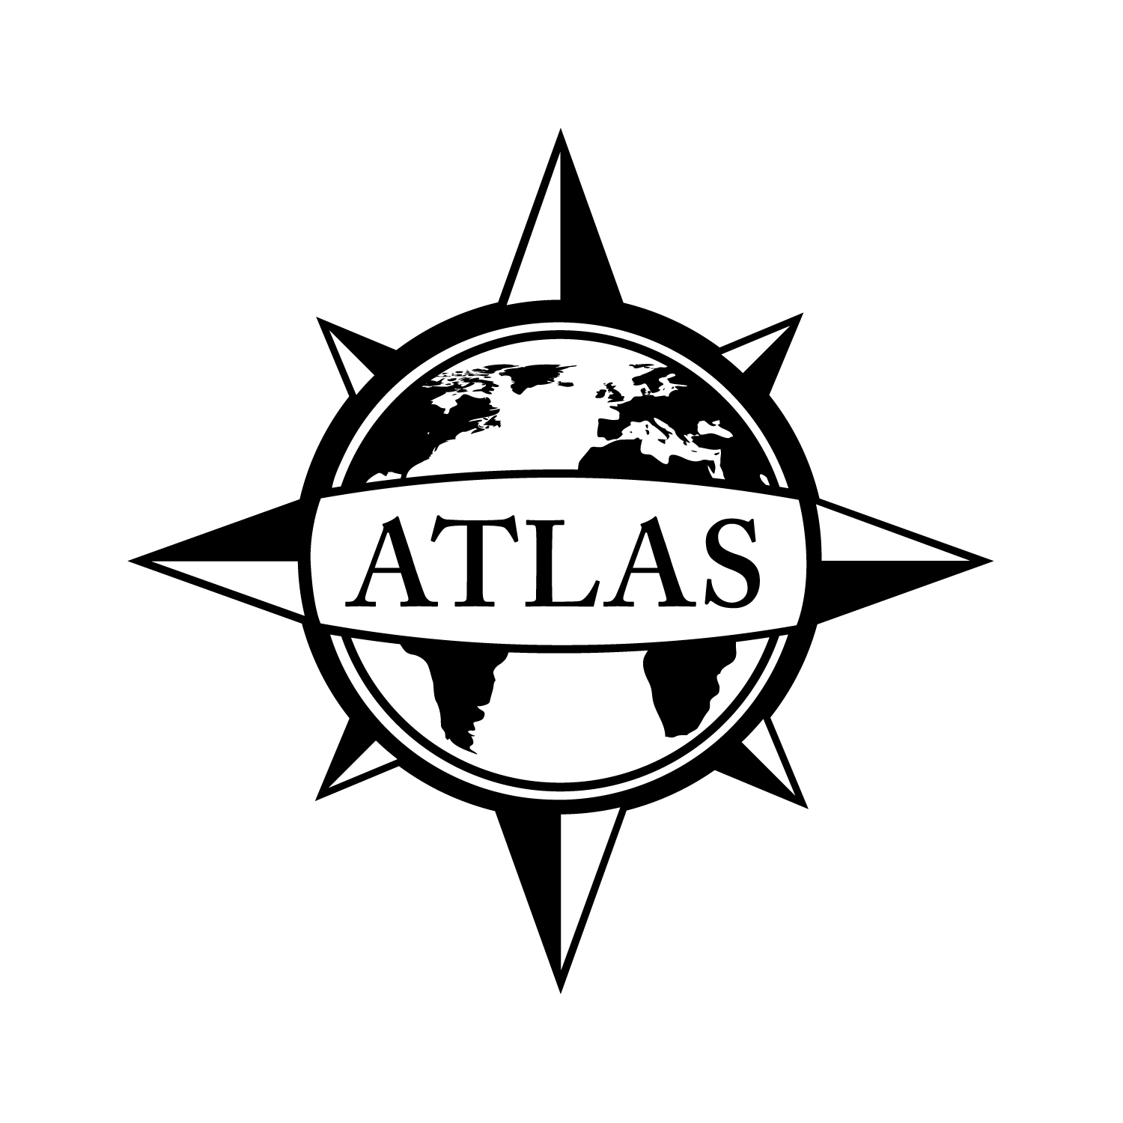
2014-2015 Minor in Latin American Studies
College of Liberal Arts
CSULB
21 Units
This checklist is not intended to replace advising from the department. Consult with the department advisor for appropriate course sequencing. Use this checklist in combination with the Academic Requirements Report, which is the official graduation verification.
 |  |  |  | Prerequisites
 | Complete ONE of the following courses (3 units total):
 |  | HIST/LAS/SOC 161: Introduction to Latin American Studies (3)  GE: Social Sciences and Citizenship (D2) |  | Corequisite: GE Composition
 |  | SPAN 445: Latin American Civilization (3) |  | Corequisite: SPAN 300

Complete 18 UNITS from the following courses in at least two disciplines (18 units total):
 | AH 457C: Pre-Columbian Art (3) | AH 111A, 111B, 112 or Consent of Instructor
 | AH 458: Art of Latin America 1800-1940 (3) | AH 111A, 111B, 112 or Consent of Instructor
 | AH 459: Art of Latin America 1940-Present (3) | AH 111A, 111B, 112 or Consent of Instructor
 | ANTH 324: Peoples of South America (3)
 | ANTH 432: Peoples of Mexico and Central America (3)
 | ANTH 440: Ethnographic Field School (3 - 6) | Consent of Program Advisor
 | ANTH 448: Ancient Civilizations of Mexico and Central America (3)
 | ANTH 490: Selected Topics in Anthropology (3) | Consent of Program Advisor
 | ANTH 499: Guided Studies in Anthropology (1 - 3) | Consent of Department and Program Advisor
 | CHLS 352/SOC 341: Central American and Caribbean Peoples in California (3)
 | CHLS 380: Chicano/Latino Theatre (3) | Upper Division Standing
 | CHLS 400: Chicana/o and Latina/o Politics in the U.S. (3)  GE: Social Sciences and Citizenship (D2) | Upper Division Standing; Consent of Program Advisor
 | CHLS 420: Chicano Heritage in the Arts of Mexico and the Southwest (3)
 | CHLS 490: Selected Topics in Chicano and Latino Studies (1 - 3) | Consent of Program Advisor
 | CHLS 499: Directed Studies (1 - 3) | Consent of Program Advisor
 | CWL 440: Selected Topics – Latin American Literary Studies (3) | One Course in Literature or Consent of Instructor
 | CWL 499: Directed Studies (1 - 4) | Consent of Program Advisor
 | ECON 490: Selected Topics in Economics (3) | Consent of Program Advisor
 | ECON 499: Directed Study (1 - 3) | Consent of Program Advisor
 | FEA 392C: Selected Topics in International Cinema: Latin American Cinema (3) | FEA 205 and 302, or Consent of Instructor
 | HIST/LAS/SOC 161: Introduction to Latin American Studies (3)  GE: Social Sciences and Citizenship (D2) | Corequisite: GE Composition
 | HIST 362: Colonial Latin America (3)  GE Social Sciences and Citizenship (D2) | GE Foundations
 | HIST 364: Latin American Nations (3)  GE: Global Issues; Social Sciences and Citizenship (D2) | GE Foundations
 | HIST 366: Latin American History and Literature (3)
 | HIST 461: History of Precolumbian Mexico (3)
 | HIST 462: Mexico (3)
 | HIST 463: The Caribbean and Central America (3)
 | HIST 466 A - C: Selected Topics in Latin American History (3) | Consent of Program Advisor
 | HIST 490: Selected Topics in History (1 - 3) | Consent of Program Advisor
 | HIST 495: Selected Topics (3) | HIST 301, 9 Units of Upper Division History, Consent
 | HIST 498: Directed Studies (1 - 3) | Consent of Program Advisor
 | POSC 358: Contemporary Latin American Politics (3)
 | POSC 481: U.S. - Latin American Relations (3) | Upper Division Standing
 | POSC 497: Selected Topics in Political Science (3) | Consent of Program Advisor
 | POSC 499: Readings and Conference in Political Science (1 - 3) | Consent of Program Advisor
 | R/ST 467: Religion in Latin America and the Caribbean (3)  GE: Global Issues; Capstone (F) or (C2) or (D2) | Upper Division Standing
 | SOC 490: Selected Topics in Sociology (1 - 3) | Consent of Program Advisor
 | SOC 499: Directed Studies (1 - 3) | Consent of Instructor
 | SPAN 341: Literary Masterpieces: Spanish America (3) | SPAN 310 or Consent of Spanish Program Director
 | SPAN 441: Studies in Nineteenth and Twentieth Century Spanish American Narrative (3) | SPAN 341 or Consent of Instructor
 | SPAN 442: Nation Building and Women’s Writing in Nineteenth-Century Spanish America (3) | SPAN 341
 | SPAN 444: Nineteenth-Century Spanish America and the National Family Romance (3) | SPAN 341
 | SPAN 445: Latin American Civilization (3) | Corequisite: SPAN 300
 | SPAN 450: Studies in Colonial Spanish American Literatures (3) | SPAN 341
 | SPAN 490: Selected Topics in Spanish (3) | SPAN 310 or Consent of Instructor
 | SPAN 492: Studies in Hispanic Theater (3) | SPAN 341 or Consent of Instructor
 | SPAN 493: Women and War (3) | SPAN 310

See online Catalog for additional course information, limitations, and requirements.

GPA Requirements  Minimum 2.0 for ALL of the following:  - Overall GPA  - CSULB GPA  - Cumulative Major/Minor GPA | Unit Requirements  120 Overall units  40 Upper Division units  30 CSULB units  24 Upper Division CSULB units | Class Unit Levels  0-29 units = Freshmen  30-59 units = Sophomore  60-89 units = Junior/Upper Division Standing  90+ units = Senior
Graduate Writing Assessment Requirement (GWAR)
Attempt the Writing Proficiency Exam (WPE) before 50 units. Transfer students must take the WPE during their first semester.

Additional Information
- Some courses and GE Capstones may count in GE and the minor. Courses in bold have been identified as GE Capstones. Visit the GE website for course selection: csulb.edu/ge.
- Students are also strongly urged to take two college intermediate level courses in Spanish, Portuguese, or any other language appropriate to the student's area of concentration.
- All Selected Topics and Independent Study courses in the area of Latin American Studies must be approved by the minor advisor.

Latin American Studies Program Location: PSY 131 Phone Number: (562) 985-4760
FO3-312 (562) 985-5192
ATLAS Network/College of Liberal Arts Advising Center Location: PH1-104 Phone Number: (562) 985-7804

File by 90!
File to graduate before your last semester.
See the Enrollment Services website for deadlines: csulb.edu/enrollment.

