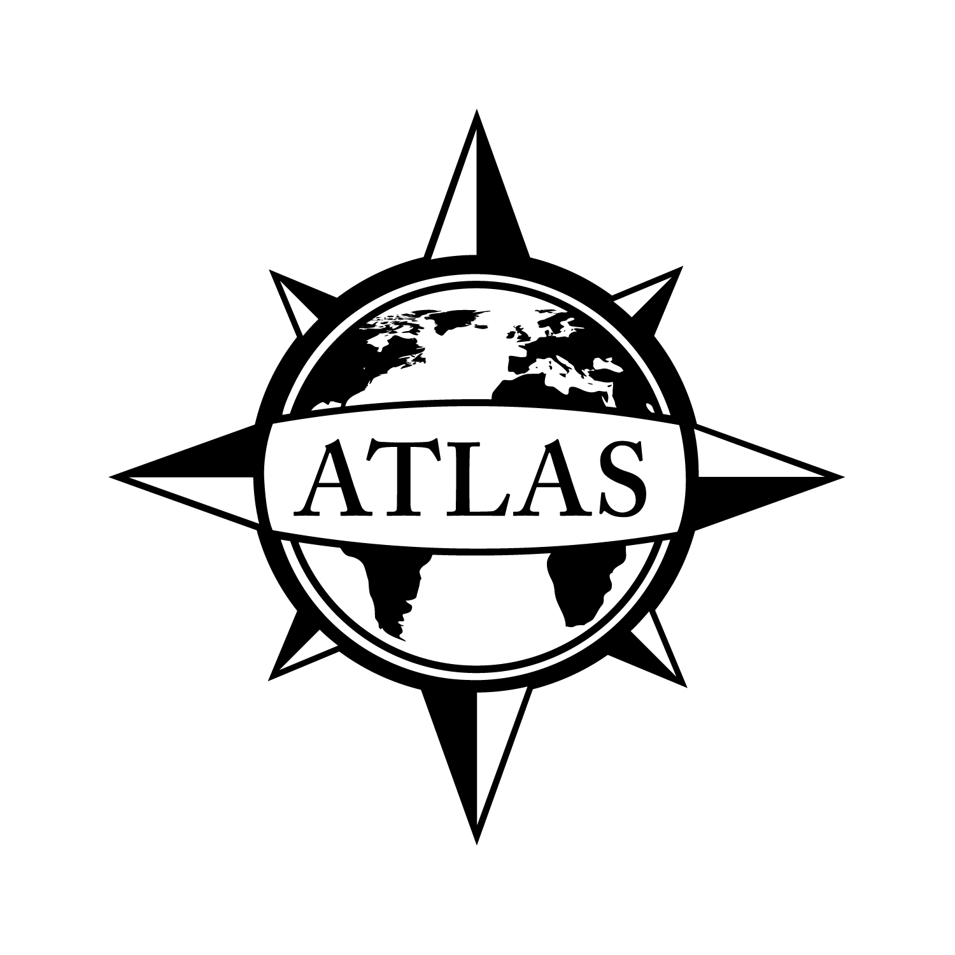
2014-2015 Bachelor of Arts in Psychology
College of Liberal Arts
CSULB
53 Units

This checklist is not intended to replace advising from the department. Consult with the department advisor for appropriate course sequencing. Use this checklist in combination with the Academic Requirements Report, which is the official graduation verification.

 |  |  | Prerequisites
Complete ALL of the following courses (14 units total):
 | PSY 100: General Psychology (3)  GE: Social Sciences and Citizenship (D2) |  | Corequisite: GE Composition
 | PSY 210/C/LA 250/HDEV 250/SOC 250: Introductory Statistics (4) |  | PSY 100, GE Composition, Eligibility for GE Math
 | PSY 220: Research Methods (4) |  | PSY 100, 210, GE Composition
 | PSY 241: Psychobiology (3)  GE: Life Science without Lab (B1aNL) |  | PSY 100, GE Composition

Complete the following course (3 units total):
 | PSY 301: Intro to Psychology as a Discipline and Profession (3) | PSY 100
Complete TWO courses from each group (12 units total):
Group I
 | PSY 331: Sensation and Perception (3) | PSY 100, 220, 241
 | PSY 332: Human Cognition (3) | PSY 100, 220, 241
 | PSY 333: Psychology of Learning (3) | PSY 100, 220, 241
 | PSY 336: Psychology of Emotion (3) | PSY 100, 220, 241
 | PSY 337: Psychology of Happiness (3) | PSY 100, 220, 241
 | PSY 340: Physiology of Behavior (3)  OR  PSY 341: Neuropsychology (3)  OR  PSY 342: Psychopharmacology (3) | PSY 100, 220, 241
Group II
 | PSY 351: Social Psychology (3)  GE: Human Diversity; Social Sciences and Citizenship (D2) | PSY 100
 | PSY 356: Personality (3)  GE: Social Sciences and Citizenship (D2) | PSY 100
 | PSY 361: Psychology of Child and Adolescent Development (3)  GE: Human Diversity; Social Sciences and Citizenship (D2)  OR  PSY 365: Psychology of Adult Development and Aging (3) | PSY 100
Select TWO Sub-Groups and complete 3 UNITS from each (6 units total):
Sub-Group A
 | PSY 354: Psychology of Women (3) | PSY 100
 | PSY 362: Autism Spectrum Disorders (3) | PSY 100
 | PSY 363: Developmental Psychopathology (3) | PSY 100
 | PSY 368: Asian American Personality and Mental Health (3) | PSY 100
 | PSY 370: Abnormal Psychology (3)  GE: Social Sciences and Citizenship (D2) or (E) | PSY 100
 | PSY 383: Women, Family, and Work Issues (3) | PSY 100
Sub-Group B
 | PSY 310: Intermediate Statistics (4) | PSY 100, 210
 | PSY 314: Psychological Assessment (3) | PSY 100, 210, 220
 | PSY 315: Principles of Psychological Testing (3) | PSY 100, 210, 220
 | PSY 359: Self-Observation and Self-Development (3) | PSY 100
Sub-Group C
 | PSY 327: Introduction to Human Factors (3)  GE: Capstone (F) or (D2) | Upper Division Standing
 | PSY 346: Evolutionary Psychology (3)  GE: Capstone (F) or (D2) | PSY 100, Upper Division Standing
 | PSY 373: Introduction to Clinical Psychology (3) | PSY 100, 370
 | PSY 375: Community Psychology (3)  GE: Human Diversity; Capstone (F) or (D2) | PSY 100, Upper Division Standing
 | PSY 378: Health Psychology (3) | PSY 100
 | PSY 381: Introduction to Industrial-Organizational Psychology (3) | PSY 100
Complete TWO 400-level Psychology courses excluding PSY 499, and no more than 3 units from 405, 406A, or 406B (6 units total):
 | Course 1:
 | Course 2:
Complete TWO upper-division Psychology courses not used to satisfy the previous requirements (6 units total):
 | Course 1:
 | Course 2:
Complete 3 UNITS from the U.S. Ethnic Studies support courses list (3 units total):
 | Course:
Complete 3 UNITS of upper division courses from any of the approved CLA departments (3 units total):
 | Course:

See online Catalog for additional course information, limitations, and requirements.

GPA Requirements  Minimum 2.0 for ALL of the following:  - Overall GPA  - CSULB GPA  - Cumulative Major/Minor GPA | Unit Requirements  120 Overall units  40 Upper Division units  30 CSULB units  24 Upper Division CSULB units | Class Unit Levels  0-29 units = Freshmen  30-59 units = Sophomore  60-89 units = Junior/Upper Division Standing  90+ units = Senior
Graduate Writing Assessment Requirement (GWAR)
Attempt the Writing Proficiency Exam (WPE) before 50 units. Transfer students must take the WPE during their first semester.

Additional Information
- Visit the Enrollment Services website to review Major Specific Declaration Requirements: csulb.edu/enrollment.
- 13 units from the major department can double count with GE requirements. Courses in bold indicate GE requirements. Visit the GE website for course selection: csulb.edu/ge.
- C/LA 250, HDEV 250, and SOC 250 are approved statistics equivalents to PSY 210.
- Students are advised to consult with the Psychology Resource Office (PSY-206) for course choices most relevant to their individual goals.

Department of Psychology Location: PSY-100 Phone Number: (562) 985-5001
ATLAS Network/College of Liberal Arts Advising Center Location: PH1-104 Phone Number: (562) 985-7804
File by 90!
File to graduate before your last semester.
See the Enrollment Services website for deadlines: csulb.edu/enrollment.

U.S. Ethnic Studies Support Courses
Africana Studies
AFRS 310: African American Male and Female Relationships (3)
AFRS/ASAM/AIS/CHLS/WGSS 319: Ethnic Experience in the U.S. (3)  GE: Human Diversity; Social Sciences and Citizenship (D2) | GE Foundations
AFRS 325: Africana Psychology (3) | AFRS 110 or PSY 100
AFRS 330: Politics of the African American Community (3) | AFRS 110 and 121
AFRS 331: African American Juvenile (3) | AFRS 210 or Consent of Instructor
AFRS 332: Civil Rights and the Law (3)  GE: Social Sciences and Citizenship (D2) | GE Foundations
AFRS 400: African-American Social Thought (3)  GE: Capstone (F) or (C2) or (D2) | Upper Division Standing
AFRS 410: The African American Family (3)  GE: Lifelong Learning and Self-Development (E) | GE Foundations and AFRS 325 or Consent of Instructor
AFRS 420: African American Children in Public Schools (3)
GE: Social Sciences and Citizenship (D2)
AFRS 423: Issues in Psychological Assessment of African Americans (3) | Upper Division Standing in Africana Studies or Consent
AFRS 475: Racism and Sexism - An Analytical Approach (3) | AFRS 332
American Indian Studies
AIS/AFRS/ASAM/CHLS/WGSS 319: Ethnic Experience in the U.S. (3)  GE: Human Diversity; Social Sciences and Citizenship (D2) | GE Foundations
AIS 335: American Indian Philosophies (3)
Anthropology
ANTH 321: North American Indians (3)
ANTH 322: California Indians (3)
ANTH 329: Cultural Diversity in California (3)  GE: Human Diversity; Social Sciences and Citizenship (D2) | GE Foundations
ANTH 419: Encounters and Identities (3)
ANTH 421/LING 425: Education Across Cultures (3)
Asian Studies
A/ST 310: United States and Asia (3) | GE Foundations
Asian-American Studies
ASAM 310: Asian Americans and Education (3)
ASAM/AIS/AFRS/CHLS/WGSS 319: Ethnic Experience in the U.S. (3)  GE: Human Diversity; Social Sciences and Citizenship (D2) | GE Foundations
ASAM 330: Japanese American Experience (3)
ASAM 331: Chinese American Experience (3)
ASAM 332: Korean American Experience (3)
ASAM 333: Vietnamese American Experience (3)
ASAM 334: Cambodian American Experience (3)
ASAM/CHLS 335: Asian and Latino Immigration Since WWII (3)  GE: Human Diversity; Capstone (F) or (D2) | Upper Division Standing
ASAM 340: Asian American Family (3)  GE: Social Sciences (D2) or (E) | Upper Division Standing
ASAM 345: Asian American Community Analysis (4)
ASAM 347: Asian Americans and Public Policy Issues (3)
ASAM 352: Filipino/a American Experience (3)
ASAM 353: Contemporary Issues in Filipino/a American Experiences (3) | Upper Division Standing
ASAM/WGSS 381: Asian American Women (3)
ASAM 370: Gender and Sexuality in Asian America (3)  GE: Social Sciences and Citizenship (D2) | Upper Division Standing
Chicano and Latino Studies
CHLS 310: Chicano Thought (3)
CHLS 319/AFRS/ASAM/AIS/WGSS: The Ethnic Experience in the U.S. (3)  GE: Human Diversity; Social Sciences and Citizenship (D2) | GE Foundations
CHLS 335: Asian and Latino Immigration Since WWII (3)  GE: Human Diversity; Capstone (F) or (D2) | Upper Division Standing
CHLS 340: Latino Education in the U.S. (3)
CHLS 350: The Latino Population in the U.S. (3)  GE: Human Diversity; Social Sciences and Citizenship (D2) | GE Foundations
CHLS 352/SOC 341: Central American and Caribbean Peoples in California (3)
CHLS 362: Chicanos and the Law (3)
CHLS 415: Latina Women in the U.S. (3) | Upper Division Standing or Consent of Instructor
CHLS 421: Street Gangs in Comparative Perspective (3)
CHLS 470: Latinas/os: Health Status and Health Care Access (3)  GE: Capstone (F) or (D2) | Upper Division Standing
Comparative World Literature
CWL 415: Ethnic Literature and Culture in America (3)  GE: Human Diversity; Capstone (F) or (C2) | Upper Division Standing
Educational Psychology
EDP 432: Social and Cultural Diversity in Educational Settings (3)
Elementary Education
EDEL 430: Social and Cultural Diversity in US Schools (3)
EDEL/LING 431: Cultural and Linguistic Diversity in Schools (3)
Health Care Administration
HCA 470: Latinas/os: Health Status and Health Care Access (3)  GE: Capstone (F) or (D2) | Upper Division Standing
Linguistics
LING 425: Education Across Cultures (3) | Upper Division Standing
LING/EDEL 431: Cultural and Linguistic Diversity in Schools (3)
LING 472: Language and Discrimination (3)
Political Science
POSC 323: Racial and Ethnic Politics - U.S. (3)  GE: Human Diversity; Social Sciences and Citizenship (D2) | GE Foundations and POSC 100
Religious Studies
R/ST 302: American Religious Diversity (3)  GE: Human Diversity; Capstone (F) or (C2) | Upper Division Standing
Sociology
SOC 340: The Latino Population in the United States (3)  GE: Human Diversity; Social Sciences and Citizenship (D2) | GE Foundations
SOC 341/CHLS 352: Central American and Caribbean Peoples in California (3)
SOC 346: Race, Gender, and Class (3)  GE: Human Diversity; Social Sciences and Citizenship (D2) | GE Foundations
Women’s, Gender, & Sexuality Studies
WGSS 315: Black Women in America (3) | GE Composition and Upper Division Standing or Consent
WGSS 318: U.S. Women of Color (3)  GE: Human Diversity; Capstone (F) or (C2) or (D2) | GE Composition and Upper Division Standing or Consent
WGSS/AFRS/AIS/ASAM/CHLS 319: The Ethnic Experience in the U.S. (3)  GE: Human Diversity; Social Sciences and Citizenship (D2) | GE Foundations
WGSS 320: Latino Women in the U.S. (3) | Upper Division Standing or Consent of Instructor
WGSS/ASAM 381: Asian American Women (3)
Approved CLA Departments
Africana Studies ▪ American Indian Studies ▪ American Studies ▪ Asian & Asian American Studies ▪ Anthropology ▪ Chicano & Latino Studies ▪ Communication Studies ▪ Comparative World Literature & Classics ▪ Economics ▪ English ▪ Environmental Science & Policy ▪ Geography ▪ History ▪ Human Development ▪ International Studies ▪ Journalism & Mass Communication ▪ Linguistics ▪ Philosophy ▪ Political Science ▪ Religious Studies ▪ Romance, German, & Russian ▪ Sociology ▪ Women's, Gender, & Sexuality Studies

