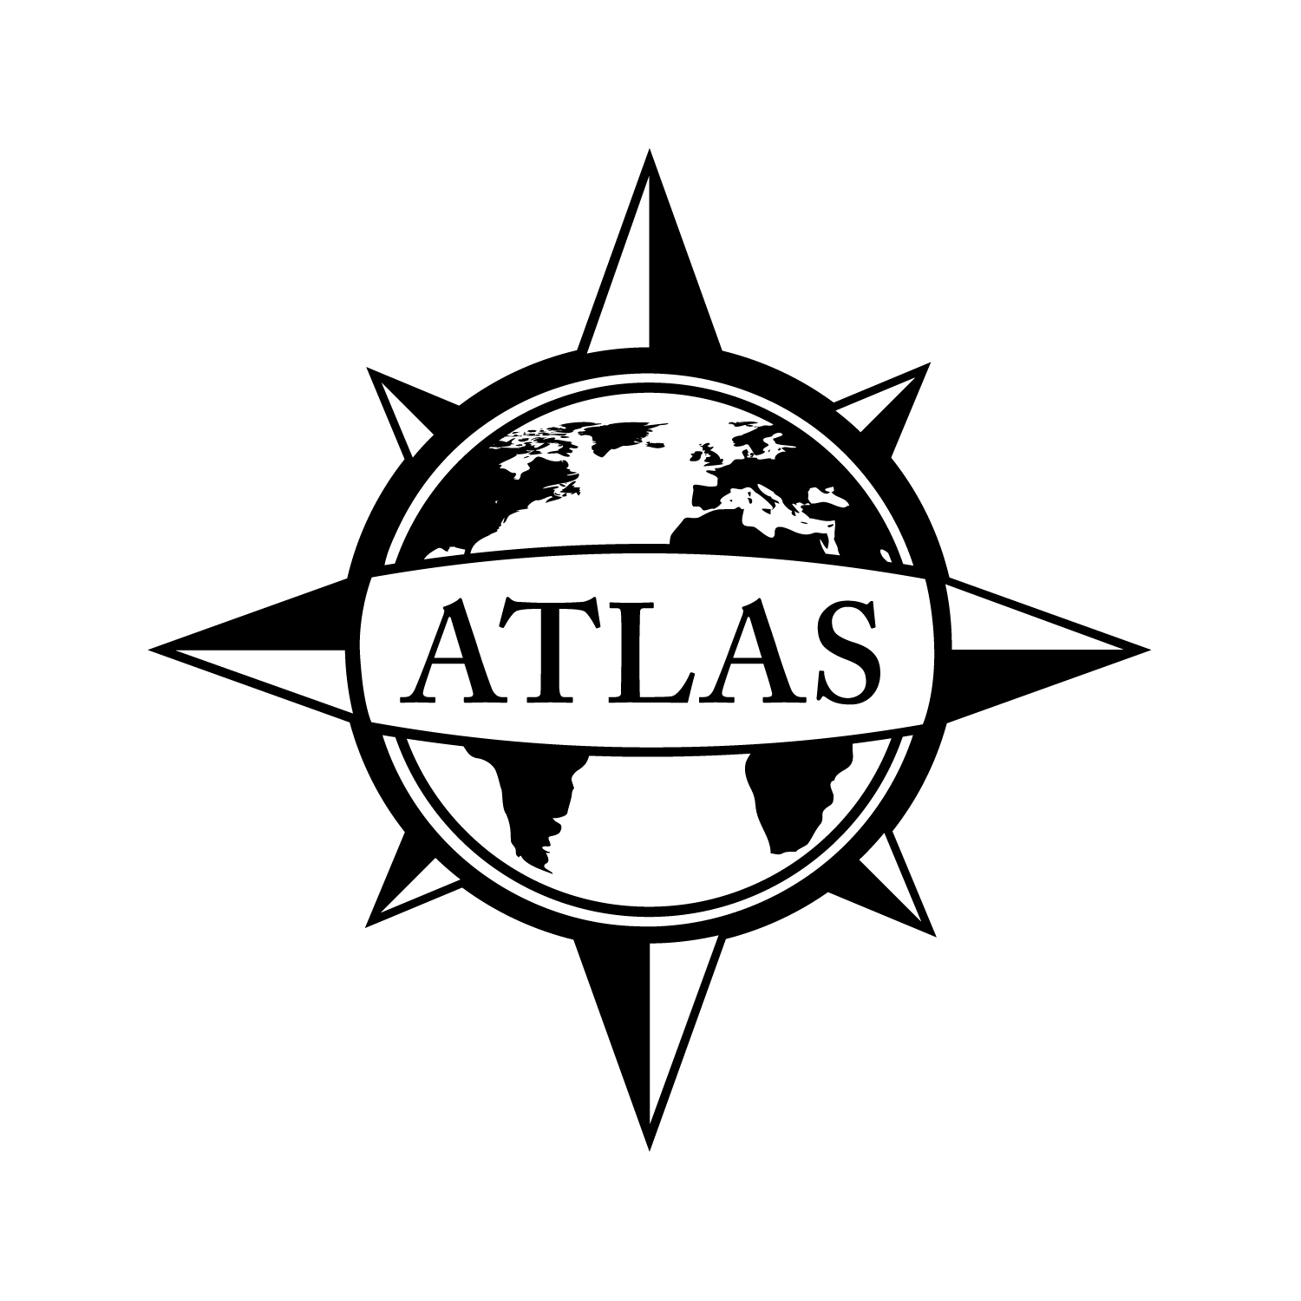
2014-2015 Minor in Russian
College of Liberal Arts
CSULB
21 Units
This checklist is not intended to replace advising from the department. Consult with the department advisor for appropriate course sequencing. Use this checklist in combination with the Academic Requirements Report, which is the official graduation verification.

 |  |  |  | Prerequisites
Complete ALL of the following courses (12 units total):
 | RUSS 100: Fundamentals of Russian (6)  GE: Humanities (C2) |  |  | Corequisite: One GE Foundation
 | RUSS 200: Intermediate Russian (6)  GE: Humanities (C2) |  |  | RUSS 100 or a Minimum of 3 Years of High School Russian; Corequisite: One GE Foundation
Complete 9 UNITS of upper division electives from the following courses (9 units total):
 |  | HIST 341A: Foundations of Russia (3)  GE: Global Issues; Social Sciences and Citizenship (D2) |  |  | GE Foundations
 |  | HIST 341B: Modern Russia (3)  GE: Global Issues; Social Sciences and Citizenship (D2) |  |  | GE Foundations or Consent of Instructor
 |  | RUSS 310: Russian Literature in English (3)  GE: Humanities (C2) |  |  | GE Foundations and Any Course in Literature or European History
 |  | RUSS 410: Introduction to Russian Civilization (3)  GE: Capstone (F) or (C2) |  |  | Upper Division Standing
 |  | RUSS 428/FEA 458: Russian Cinema (3) |  |  | Upper Division Standing
 |  | RUSS 499: Directed Studies (1 - 3) |  |  | Senior Standing and Consent of Instructor

See online Catalog for additional course information, limitations, and requirements.

GPA Requirements  Minimum 2.0 for ALL of the following:  - Overall GPA  - CSULB GPA  - Cumulative Major/Minor GPA | Unit Requirements  120 Overall units  40 Upper Division units  30 CSULB units  24 Upper Division CSULB units | Class Unit Levels  0-29 units = Freshmen  30-59 units = Sophomore  60-89 units = Junior/Upper Division Standing  90+ units = Senior
Graduate Writing Assessment Requirement (GWAR)
Attempt the Writing Proficiency Exam (WPE) before 50 units. Transfer students must take the WPE during their first semester.

Additional Information
- Some courses and GE Capstones may count in GE and the minor. Courses in bold indicate GE requirements. Visit the GE website for course selection: csulb.edu/ge.
- The Minor in Russian is available to any non-Russian major.

Department of Romance, German, Russian Languages and Literatures Location: AS-309 Phone Number: (562) 985-4318
ATLAS Network/College of Liberal Arts Advising Center Location: PH1-104 Phone Number: (562) 985-7804

File by 90!
File to graduate before your last semester.
See the Enrollment Services website for deadlines: csulb.edu/enrollment.

