How to Sign Up for a College of Liberal Arts Workshop

Step 1 Go to http://cla-web1.campus.ad.csulb.edu/Workshops/SignUp.aspx to sign up for your workshop.

Step 2 Fill in the required information, and click on “Make an appointment.”
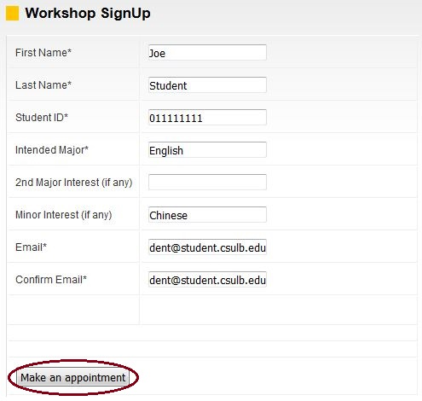

Step 3 Click on the “+” to bring up a list of the workshops available.
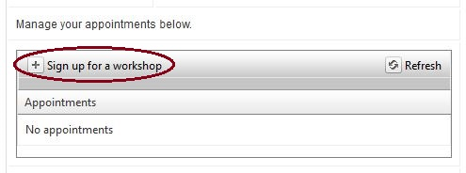

Step 4 Select the workshop you want to attend from the drop-down list. The number of available seats in each workshop is listed on the right. Click on “Save” once you have selected the day and time you want.

Step 5 Click on “Confirm.”
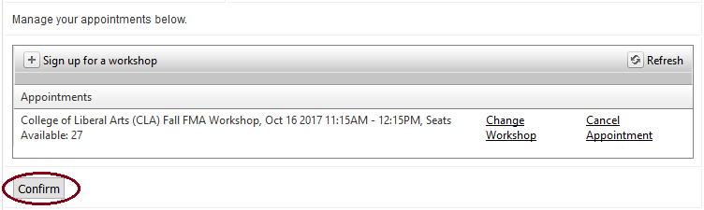

Step 6 Your signup was successful! Print a copy of the confirmation screen for your records. You will receive a confirmation email shortly.
