**J o u r n a l i s m 3 0 5 :**

M e d i a D e s i g n

Syllabus for Spring 2014

‘‘As with any other product, we’re tossed out there in the marketplace with a price tag. If people want to buy, whoopee – if not, that’s the way the cookie crumbles, and the newspaper folds. For a measly 15 cents, in fact, I can’t think of a better bargain. Check out your company’s vending machines. A dried-up, old doughnut costs you 30 cents. We’re worth at least half as much as a dried-up, old doughnut. Or a cup of bad coffee for 20 cents. If nothing else, we’re something to disagree with and swear at on a particularly trying day.’’

–**Mike Royko**

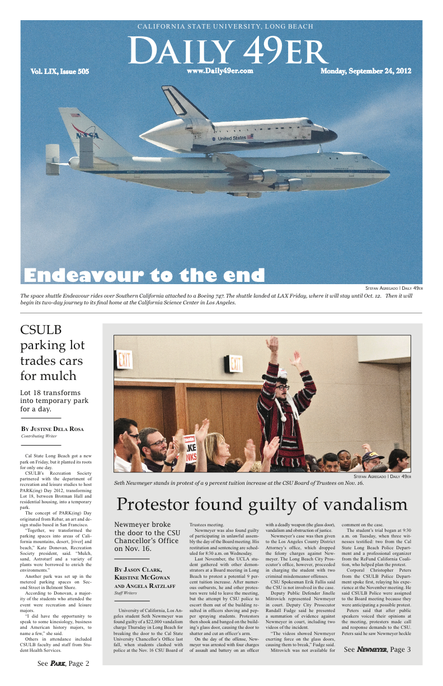**Mondays and Wednesdays 8 a.m. to 9:50 a.m.**

**Section:** 03 and 04

**Classroom:** SPA 005

Professor Gary Metzker

**E-mail:** [gary.metzker@csulb.edu](mailto:gmetzker@csulb.edu)

**Office hours:**  10 a.m. to noon Tuesdays and Thursdays or you can e-mail me or set up an appointment

**Office location:** SPA Room 009A

**Pre-requisites**

JOUR 311 with a grade of C or better or consent of instructor

**Required textbook**

Newspaper Designer Handbook, Seventh Edition, by Tim Harrower

**Required reading (one or two of the following every day)**

Los Angeles Times/ Long Beach Press Telegram/ Long Beach Register/ New York Times/ Wall Street Journal/ USA Today/ The Guardian

**Required Web site reading (every day)**

[www.newseum.org](http://www.newseum.org)

[charlesapple.com](http://www.apple.copydesk.org)

**Required materials**

Notepad for sketching

Flash/USB driver – 2 GB or more

**Overview**

This class will try to prepare you to design for old and new media, thoughtfully and with relevance. From newspapers to public relations brochures to magazine spreads, always remember one thing: Is what I am doing going to help someone, somewhere, learn something they do not already know?

We will take a look at the history of design, type and fonts. We will study layouts, photos, graphics and color and what they communicate to your audience. This is a hands-on class. You will design newspapers, brochures, reinvent logos, newsletters and photo spreads. By the end of class, you will know the difference between bumping heads and doglegs and you will uncover the secret of the CVI. You will learn the difference between a point and a pica and the basics of Adobe InDesign.

**Objectives**

By May, you should know the difference between leading and kerning; between popouts and mortices and vertical and horizontal design. You will have a working knowledge of InDesign and be proficient in design for a variety of media.

**Philosophy**

News design is about information as much as decoration. Think of yourselves as visual journalists, not just decorators. You will be the newsroom experts on how to combine text, graphics and photos to explain stories to readers.

**Attendance**

Guess what? Attendance is mandatory. Come prepared to participate in class discussions. Your participation is so important to me that significant course credit will be attached to your attendance and making relevant, thoughtful comments during our meetings. I mean, how can you build award-winning layouts if you are not here? You are expected to be in class on time. Attendance will be taken every day. Arriving late and/or leaving early will result in your being considered absent. You are allowed two absences or late arrivals. After that, you will lose **one point** from your final grade every time you are absent or arrive late.

Additionally, you will come to my office for a chat . . . twice . . . with one visit coming before spring break. This is part of your class participation grade. This gives me a chance to get to know you and for you to share any concerns you are having with class. Of course, you can visit as many times as you want and share a pretzel with me!

Finally, cell phones must be turned off when you enter class. If you are caught using your phone during class, you will be asked to leave. If I have to ask you more than once during the semester, you will be dropped from class.

**Respect the deadline**

Can you publish a newspaper or a magazine or run a website and miss a deadline? Absolutely not! Please let me know if there are special circumstances (illness, family emergency, etc.) and be prepared to document the circumstance. Projects are due at the beginning of class unless stated otherwise. Homework assignments are due at the beginning of class unless stated otherwise. I reserve the right to change the syllabus depending on how well the class as a whole is progressing. If I drop an assignment, for example, the final grading system will be adjusted. If you choose to turn an assignment in late, you will be penalized as follows:

Same day, but not turned in at the beginning of class: -5%

One day late: - 10%

Two days late: - 20%

Three days late: - 30%

Four days late: - 40 %

More than four days late = 0 on that assignment

**Quizzes and exams**

You will be quizzed on current events and information gleaned from your chapter readings. Some quizzes will be unannounced, so please be prepared. Your two exams will be true/false, multiple choice, short answer and InDesign.

**Projects**

**Newspaper layout:** You and a partner will take the front page of a well-known newspaper that I assign and give it a different look. You will be expected to change the typography, balance, size and other aspects that define the publication you are mimicking. **Value: 5 points. Deadline: Feb. 19**

**Photo layout:** You will work with the photos from the Los Angeles Times or New York Times website and on a 78 pica x 108 pica page create a photo page. Keep in mind what you learn in class about photo design and photography. Your layout should contain at least three photos and no more than five. Each photo should have a caption and a photo credit or your photos should have a copy block with a headline. Your projects will be on display at Journalism Day. **Value: 8 points. Deadline: March 26**

**Corporate project:** Get together with a partner and create a public relations newsletter and reinvent the logo of a famous or not so famous company. Your newsletter needs to have a logo/flag at the top and your story (or stories) needs to have a photo or two on it. Also, you will create a business card with your name on it. This project will be produced on 51 pica x 66 pica page. **Value: 12 points. Deadline: April 30**

**Psst! Wanna get an A?** (Thanks to Dr. Danny Paskin, who also teaches J-405.)

1. Study the chapters before class and actually understand the subject matter. 2. Attend all classes and be on time. 3. Ask questions. 4. Sit in the front row. 5. Do extra credit, if offered. 6. Come talk to me during office hours if you have any problems at all, or e-mail me. 7. Always make sure I go over a project with you before it is due. 8. Follow directions. 9. Make sure I know your name. 10. Turn in projects on time. 11. At all times, be creative!

**Grading scale for page designs**

F - Page is late  
D - Page has serious flaws and/or grammatical errors  
C - Page is generally well designed, but has some flaws  
B - Page is clean, well-designed and some elements exceed expectations for publication.  
A - Page goes the extra mile. Designer has met all basic standards AND added extras to enhance readability and overall aesthetics.

Please note that a C is considered the baseline grade. Your work will need to be exceptional to get a higher grade.

**Making the grade**

90% - 100% = A

80% - 89% = B

70% - 79% = C

60% - 69% = D

Below 60% = F

**Earning the points**

Projects 25 points

Exams (midterm and final) 50 points

Quizzes 10 points

Class participation 15 points

**TOTAL** 100 points

**Anticipated Course Outline**

**Week 1 (Jan. 22)**

Welcome/ Introductions/ Course requirements

**Week 2 (Jan. 27-29)**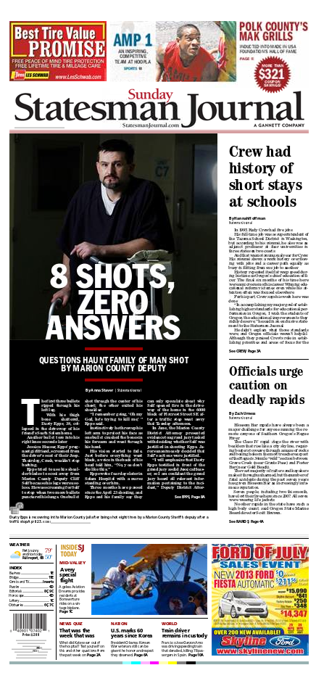

Chapter 1: Fundamentals

InDesign training

**Week 3 (Feb. 3-5)**

Chapter 2: Story design and InDesign training

**Week 4 (Feb. 10-12)**

Chapter 2 and 8: Story design, Redesigning and InDesign training

**Week 5 (Feb. 17-19)**

Chapter 3: Page design and InDesign training

**Project #1 due Feb. 19**

**Week 6 (Feb. 24-26)**

Chapter 3: Page design

Field trip to Los Angeles Times (tentative)

**Week 7 (March 3-5)**

Chapter 4: Photos and InDesign

Guest speaker from the Los Angeles Times

**Week 8 (March 10)**

Out-of-class assignment on March 12.

Work on photo layout project and InDesign

**Week 9 (March 17-19)**

Midterm review

**MIDTERM March 19**

**Week 10 (March 24-26)**

Chapter 5: Nuts and bolts and InDesign

Project #2 due March 26

**Week 11 (March 31-April 2)**

**SPRING BREAK!!!!!**

**Week 12 (April 7-9)**

Newsletters and InDesign

Public relations and InDesign

**Week 13 (April 14-16)**

Logos and InDesign

**Week 14 (April 21-23)**

Chapter 9: The Internet and InDesign

Work on project 3

**Week 15 (April 28-30)**

Work on project 3

**Project #3 due April 30**

**Week 16 (May 5-7)**

Final review and InDesign practice

**FINAL: 8 a.m. to 10 a.m., May 12**

**Department of Journalism & Mass Communication**

**Policies on Grading, Conduct of Classes, Drops, Absences and Cheating**

Grading: The grading policies and practices in this class are explained elsewhere in the syllabus. It is the student’s responsibility to read them and to seek clarification if necessary. The student should be fully aware of what is required for success in the course, such as group participation, writing, speaking, completing assigned readings, etc.

Seat in Class: An enrolled student may lose his/her seat in class if he/she misses the first class meeting without notifying the instructor. At the instructor’s discretion, a student who attends the first class but not subsequent classes may also be dropped from the course.

Withdrawal from Class: Students may withdraw from a class from the third to the 12th week for “serious and compelling reasons.” Normally these are defined as anything of import that is beyond the control of the student. This includes, but is not necessarily limited to, death or serious illness in a student’s immediate family or a documented change in a student’s work schedule. Poor performance, tardiness and unexcused absences are not considered a serious or compelling reason beyond the student’s control for purposes of withdrawal.

Absences from Class: Grades in a course may be adversely affected by absences, and students should seek clarification from the instructor regarding the course absence policy. Make-ups usually are granted in strict accordance with CSULB policy, which defines excused absences as (1) illness or injury to the student; (2) death, injury or serious illness of an immediate family member or the like; (3) religious reasons; (4) jury duty or government obligation; (5) CSULB-sanctioned or approved activities [2002-03 Catalog, p. 75]. These and any other requests for an excused absence must be documented.

CSULB Cheating/Plagiarism/Fabrication Policy: CSULB takes issues of academic dishonesty very seriously. If you use any deceptive or dishonest method to complete an assignment, take an exam, or gain credit in a course in any other way, or if you help someone else to do so, you are guilty of cheating. If you use someone else’s ideas or work and represent it as your own without giving credit to the source, you are guilty of plagiarism. This does not apply if the ideas are recognized as common knowledge, or if you can show that you honestly developed the ideas through your own work. Any instructor can show you the correct ways of citing your sources, and you should use quotation marks, footnotes or endnotes and bibliographic references to give credit to your sources according to the format recommended by your instructor.

Responses, Penalties and Student Rights: Students should consult the appropriate sections of the Catalog for examples of cheating, fabrication and plagiarism, and instructor and/or CSULB response options in such circumstances. The Catalog also outlines student rights. Any instance of academic dishonesty may result in your immediate expulsion from the class with a grade of “F” and/or other sanctions, as the instructor deems appropriate.

**Student Learning Assessment**

The national accrediting agency for journalism education has established a requirement that all accredited journalism schools assess student mastery of 12 core values and competencies that any graduate of a journalism and mass communication program should possess. According to the Accrediting Council on Education in Journalism and Mass Communication (ACEJMC), all graduates, irrespective of their particular specialization, should be able to:

1) Understand and apply principles of law of freedom of speech and press for the United States, as well as receive instruction in and understand the range of systems of expression around the world – including the right to dissent, to monitor and criticize power, and to assemble and petition for redress of grievances.

2) Demonstrate an understanding of the history and role of professionals and institutions in shaping communications.

3) Demonstrate an understanding of gender, race, ethnicity, sexual orientation and, as appropriate, other forms of diversity in the United States in relation to mass communications

4) Demonstrate an understanding of the diversity of peoples and cultures and of the significance and impact of mass communications in a global society.

5) Understand concepts and apply theories in the use and presentation of images and information.

6) Work ethically in the pursuit of truth, accuracy, fairness and diversity.

7) Think critically, creatively and independently.

8) Conduct research and evaluate information by methods appropriate to the communications professionals in which they work.

9) Write correctly and clearly in forms and styles appropriate for the communications professions, audiences and purposes they serve.

10) Critically evaluate their own work and that of others for accuracy and fairness, clarity, appropriate style and grammatical correctness.

11) Apply basic numerical and statistical concepts.

12) Apply current tools and technologies appropriate for the communications professions in which they work, and to understand the digital world.