California State University, Long Beach

JOUR 312I-02 (3717)
GLOBAL NEWS MEDIA

Online Course
Spring 2016

Professor: Dr. Heloiza G. Herscovitz

http://www.csulb.edu/colleges/cla/departments/journalism/people/herscovitz.htm

Office: LA 4, 206 D
Office hours: consult me by email

E-mail: heloiza.herscovitz@csulb.edu
(Please, include Jour 312I (02) and your full name in the subject line)
Phone: (562) 985-5667 (e-mail is better!)
For tech problems consult Tech help

Course Description and Objectives:

This is a GE interdisciplinary capstone course that brings the world to the classroom by connecting globalization and media concepts to international news. It focuses on global news media structure and characteristics, multimedia practices and operations, war coverage, international news flow, and the impact of new technologies on news selection, construction and consumption. This course has three main purposes: 1. Help students to develop a general understanding of mass communication and globalization theories and how they apply to different regions of the world and to top global events. 2. Offer students the elements to explain and synthesize economic, political, social and cultural influences that drive the global news coverage, and the changing media landscape, including global advertising and public relations. 3. Train them to develop sharp critical thinking skills about ethnocentrism, diversity and inequalities in the global media system. Special attention is devoted to understanding how the world's leading media houses operate in distinct political settings, and the differences and similarities between Western and non-Western media outlets.

Learning Outcomes

At the end of this course, students will be able to:

- Understand the main characteristics of global media systems and how digital technologies affect the circulation of information in the world.
- Discuss Western ethnocentrism and biases in international news flow, global entertainment, advertising and public relations.
- Apply theories of mass communication and globalization to particular regions and media events.
- Describe key global media players, international professional norms and patterns of coverage of major issues.
- Classify geopolitical regions and their media features.
- Assess economic, political, social and cultural influences on global news systems.
- Reflect critically on what governments, news organizations and citizens can do to improve diversity of viewpoints, press freedom and social development.

Assessment and Modes of Instruction:

Student will be assessed through quizzes on current news, tests on course content, essays and research projects, presentations, short online assignments, and class discussions. This course is fully online and all the content is posted on BeachBoard

Course Readings

Please, purchase the book “The World News Prism, Digital, Social and Interactive,” by William A. Hachten and James F. Scotton, 2015, 9th edition (Wiley Blackwell).
Bring it to every class.

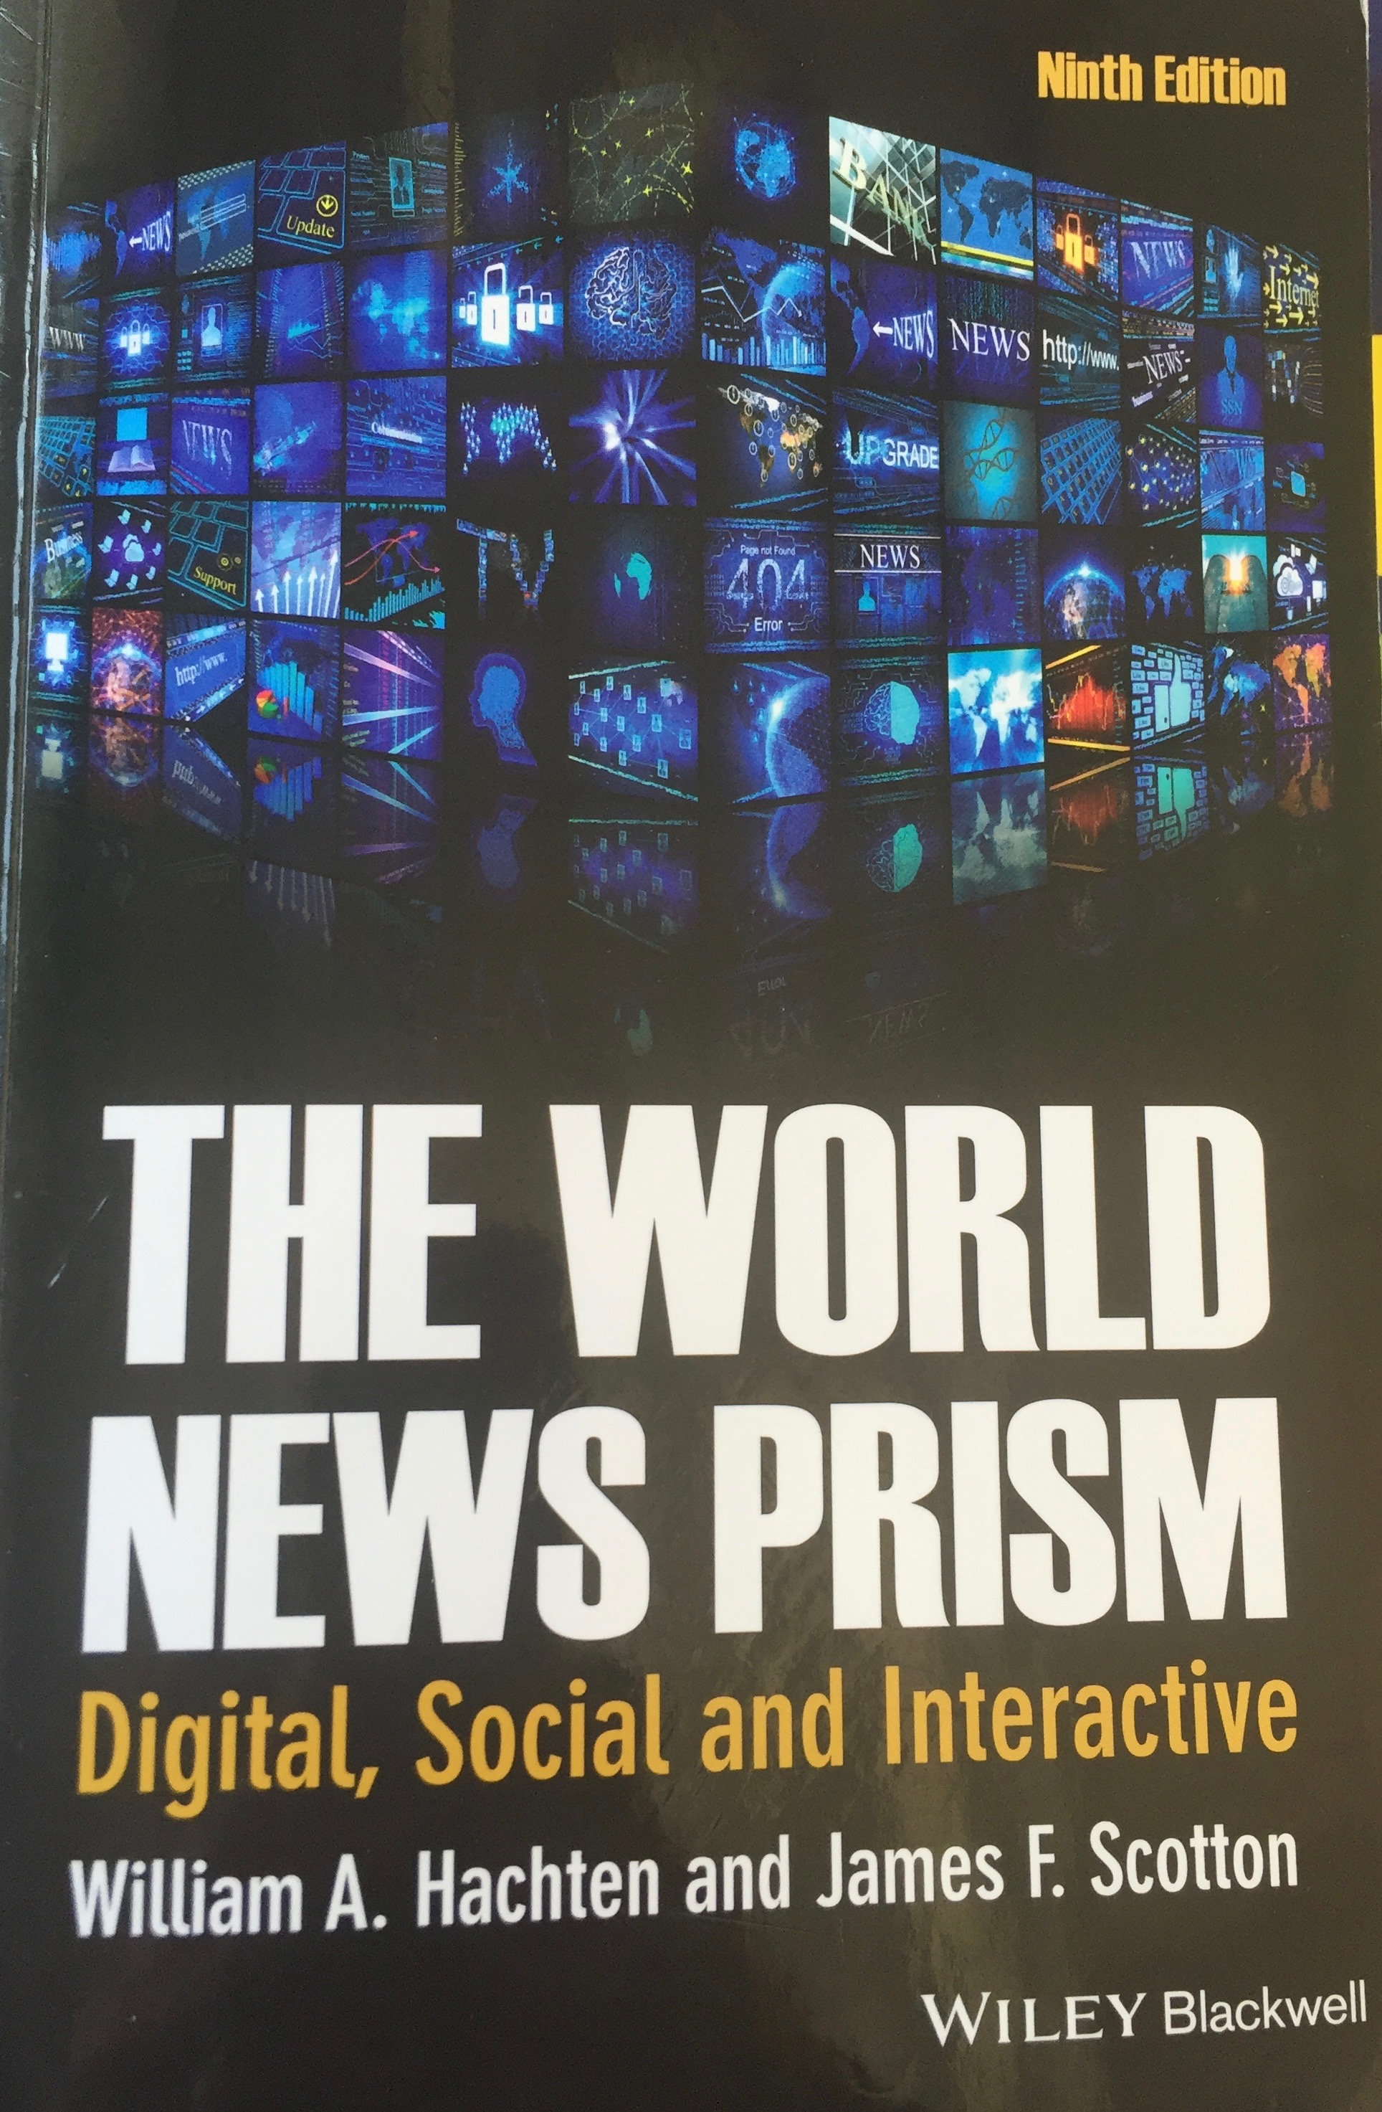

Additional readings are posted on BeachBoard as well.

Buy a digital student subscription of The Economist for 12 weeks ($12) at The Economist
There will be several quizzes on current news based on it.

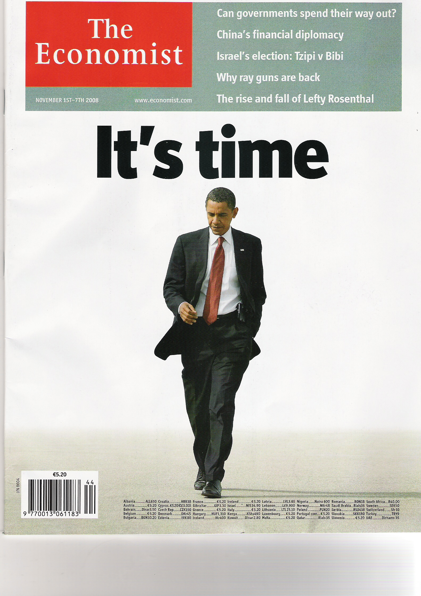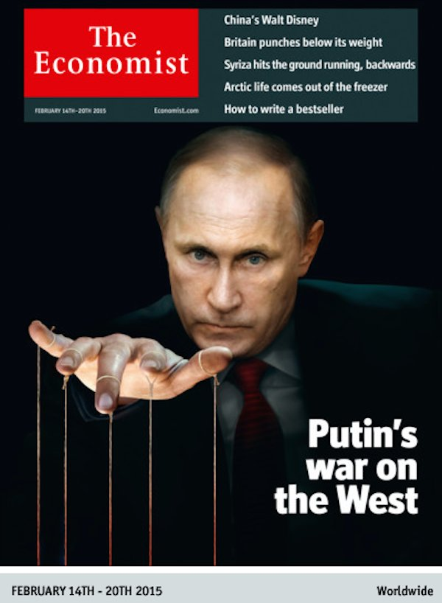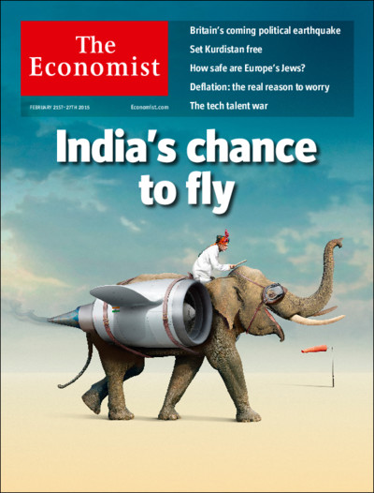

Important news sources:

The Los Angeles Times (www.latimes.com) section World
The Wall Street Journal (http://online.wsj.com/public/us) section World (look at all regions)
The Associated Press
http://hosted.ap.org/dynamic/fronts/WORLD?SITE=AP&SECTION=HOME
Reuters: http://www.reuters.com
BBC world news (http://www.bbc.com/news/world/)
CNN (http://www.cnn.com/WORLD/?hpt=sitenav.com)
Al Jazeera (http://english.aljazeera.net)
NPR world news (http://www.npr.org/sections/world/)

You can follow these media outlets on Twitter and Facebook as well.

Requirements for Written Assignments

Everything you write in this course needs to have a creative title. No need to produce a cover sheet the assignments. I expect your work to be well written and well edited. Your work should be double-spaced, with paragraph indents and without extra spacing between paragraphs. Use Times New Roman 12 point-font. Save your work in Word (doc or .docx); do not use .pdf. Pay attention to spelling, accuracy, clarity and grammar. Poorly written assignments will be penalized. Add number your pages, your name and word count on the top of the first page. Any instance of plagiarism, fabrication of sources or other information will be grounds for failure in this course. Also, use APA style for all in-text citations and bibliography. Do not use Wikipedia as a source.
Check rubrics for assignments on course content.

Check these websites on how to write essays and use APA style:
APA Purdue (https://owl.english.purdue.edu/owl/resource/685/01/)
Purdue Essays (https://owl.english.purdue.edu/owl/resource/560/01/)

Grading

Grades will be based on your ability to describe, understand, apply, analyze, synthesize, and evaluate evidence and offer conclusions. Originality, quality of writing, creativity, adherence to journalistic principles, grammar, punctuation and style also count.

Assignments

Mid Term 100 points (20%)
Final Exam 100 points (20%)
Final Project 100 points (20%)
Short Essay 50 points (10%)
Short Assignments (5) 50 points (10%)
Discussion Boards (6) 30 points (6%)
Quizzes on current events (7) 70 points (14%)

Total Points: 500

A= + 450 points (outstanding performance)
B= 400 - 449 points (superior performance)
C= 350- 399 points (adequate performance)
D= 300 -349 points (marginal performance)
F= Below 299 points (unacceptable performance)

If, at the end of the semester, you miss the cutoff by one point, I will automatically move your final grade up to the next grade.

Deadlines and Policy on Late Work:
Assignments submitted via Beachboard have a cutoff time to be uploaded to Beachboard, which is 11:59 pm on the day they are due. Plan accordingly because technical difficulties do happen and they won’t concern me. Please, do not ask for cancellation of penalties if you submit late work. Essay or short assignments turned in one the same day but after the deadline will be marked down 10 points. On the second day it will be marked down 20 points. On the third day it will be marked down 30 points. After that they will receive a zero. Late work may be accepted if you have adequate supporting documentation in strict accordance with CSULB policy (read below) such injury, illness, jury duty, etc. and my consent. Do not send assignments by email unless instructed by me. Discussion Boards on module topics will be marked down 5 points if turned in in the first 24 hours after the deadline. After that they will be worth 1 point only.

There is no make up for quizzes or exams. If you miss the midterm, points will be transferred to the final exam, which will be worth 200 points.

Cheating and Plagiarism

Any student caught cheating or plagiarizing at any time and on any type of assignment risks receiving an “F” for the course at the instructor’s discretion. Additionally, a copy of the offense may be forwarded to the Office of Judicial Affairs for review and potentially action on your permanent school record. Ignorance of what constitutes plagiarism or cheating is not a valid excuse. Please read the CSULB policy on Turnitin at http://www.csulb.edu/lats/itss/bb/faculty/turnitin_assignments.html

How to prevent plagiarism? It is easy: when paraphrasing or quoting others, offer the sources and reference them according to APA rules.
http://en.writecheck.com/ways-to-avoid-plagiarism/

Assignments

Mini Quizzes (7): Quiz format includes multiple choice and truth/false questions based on your weekly readings of The Economist, mostly the World Politics + Business and Finance sections. Dates for quizzes are announced in the tentative course schedule based on the magazine’s weekly edition. Make sure you have a digital subscription of The Economist ($1 a week) on day one. Once you enter the homepage, log in and click on Print edition on the top right corner of the page. Then click on current issue.

Mid-Term and Final Exam: Test format include multiple choice and true/false questions. Dates are announced in the tentative course schedule. A detailed study guide for both exams will be posted in our course homepage. Also, the Q&A permanent forum will be the place to ask questions about the exams.

Short Assignments: Essay style reactions to events or answers to questions posed by me. Length: between 200 and 300 words (always check the required length for each one). You need to include sources/short bibliography. Grammar counts. Check rubric please.

Short Essay: Analysis of a topic related to war reporting based on course content and the films Live from Baghdad and Control Room. Use APA style for in-text citation and bibliography; write in third person in a formal style; follow instructions and rubric posted in our homepage. Length: 600 words. Check rubric please.

Live from Baghdad: https://youtu.be/G1dgOoE0O6I
Control Room: https://youtu.be/f3rMo5cgaXQ

On a separate document you will find detailed instructions for this assignment.

Discussion Boards: Forums on different topics and current events. Grammar counts.

Final Project: You will produce a mini framing analysis of how the Economist portrays one of the following in the last 12 months.. These countries comprise chapters 6, 7, 8, 9 and 10 of out textbook. See further details on the final project on a separate document.

- Brazil
- Russia
- India
- China
- One or more African countries

Other Important Observations:

Grading: The grading policies and practices in this class are explained elsewhere in the syllabus. It is the student’s responsibility to read them and to seek clarification if necessary. The student should be fully aware of what is required for success in the course, such as group participation, writing, speaking, completing assigned.

Seat in Class: An enrolled student may lose his/her seat in class if he/she misses the first class meeting without notifying the instructor. At the instructor’s discretion, a student who attends the first class but not subsequent classes may also be dropped from the course.

Withdrawal from Class: Students may withdraw from a class from the third to the 12th week for “serious and compelling reasons.” Normally these are defined as anything of importance that is beyond the control of the student. This includes, but is not necessarily limited to, death or serious illness in a student’s immediate family or a documented change in a student’s work schedule. Poor performance, tardiness and unexcused absences are not considered serious or compelling reasons beyond the student’s control for purposes of withdrawing.

Absences from Class: Grades in a course may be adversely affected by absences, and students should seek clarification from the instructor regarding the course absence policy. Make-ups usually are granted in strict accordance with CSULB policy, which defines excused absences as (1) illness or injury to the student; (2) death, injury or serious illness of an immediate family member or the like; (3) religious reasons; (4) jury duty or government obligation; (5) CSULB-sanctioned or approved activities [2002-03 Catalog, p.75]. These and any other requests for an excused absence must be documented.

CSULB Cheating/Plagiarism/Fabrication Policy: CSULB takes issues of academic dishonesty very seriously. If you use any deceptive or dishonest method to complete an assignment, take an exam, or gain credit in a course in any other way, or if you help someone else to do so, you are guilty of cheating. Making something up constitutes fabrication. If you use someone else’s ideas or work and represent it as your own without giving credit to the source, you are guilty of plagiarism. This does not apply if the ideas are recognized as common knowledge, or if you can show that you honestly developed the ideas through your own work. Any instructor can show you the correct ways of citing your sources, and you should use quotation marks, footnotes or endnotes and bibliographic references to give credit to your sources according to the format recommended by your instructor. The Department of Journalism has a zero-tolerance policy in these areas, and any instance of academic dishonesty -- cheating, plagiarism and/or fabrication -- may result in your failing of the assignment, immediate removal from class with a failing grade, removal from the College of Liberal Arts, expulsion from the university and/or other sanctions as the instructor deems appropriate.

Responses, Penalties and Student Rights: Students should consult the appropriate sections of the Catalog for examples of cheating, fabrication and plagiarism, and instructor and/or CSULB response options in such circumstances. The Catalog also outlines student rights.

Students with Disabilities:
Students with disabilities who need assistance or accommodation to participate in the course should inform the instructor and then contact Disabled Student Services within the first week of class. In addition, students should establish their eligibility for assistance by contacting the Disabled Student Services Office (Brotman Hall 270) at 562-985-5401.
Students are to provide the instructor verification of their disability from Disabled Student Services. If the service offered is insufficient or inadequate, the student should confer with the instructor and the director of Disabled Student Services. If these efforts are unsuccessful, students have the option of directing their concerns to the Office of Equity and Diversity (University Student Union 301) at 562-985-8256. Responsibility for oversight and implementation of the Americans with Disabilities Act and the Rehabilitation Act has been delegated to the campus director for disability support and accommodation.

Student Learning Assessment

The national accrediting agency for journalism education has established a requirement that all accredited journalism schools assess student mastery of 12 core values and competencies that any graduate of a journalism and mass communication program should possess. According to the Accrediting Council on Education in Journalism and Mass Communication (ACEJMC), all graduates, irrespective of their particular specialization, should be able to:

- Understand and apply principles of law of freedom of speech and press for the United States, as well as receive instruction in and understand the range of systems of expression around the world – including the right to dissent, to monitor and criticize power, and to assemble and petition for redress of grievances.
- Demonstrate an understanding of the history and role of professionals and institutions in shaping communications.
- Demonstrate an understanding of gender, race, ethnicity, sexual orientation and, as appropriate, other forms of diversity in the United States in relation to mass communications
- Demonstrate an understanding of the diversity of peoples and cultures and of the significance and impact of mass communications in a global society.
- Understand concepts and apply theories in the use and presentation of images and information.
- Work ethically in the pursuit of truth, accuracy, fairness and diversity.
- Think critically, creatively and independently.
- Conduct research and evaluate information by methods appropriate to the communications professionals in which they work.
- Write correctly and clearly in forms and styles appropriate for the communications professions, audiences and purposes they serve.
- Critically evaluate their own work and that of others for accuracy and fairness, clarity, appropriate style and grammatical correctness.
- Apply basic numerical and statistical concepts.
- Apply current tools and technologies appropriate for the communications professions in which they work, and to understand the digital world.

